Report

Ziyang Lin zlin32

Dataset

Model Architecture

I used three different CNN model for classifying the CIFAR-100. The first one is the simple convolutional network model

Model result

Cnn

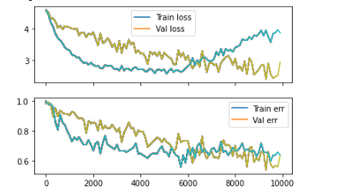

Resnet

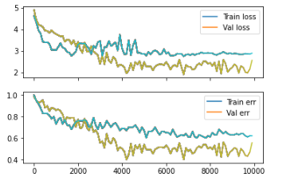

Vgg

